Javascript Practical Exam2 19-04-2024

Instructions:

* Complete the coding exercises within the 2hrs.
* Answer the theoretical questions concisely, demonstrating your understanding of the concepts.
* Once you finish the exam, submit your solutions to below link.

<https://drive.google.com/drive/folders/1sg4IQI2MCiH-SGENkogX7cNWUfxkckyx?usp=sharing>

**Section 1: Coding Exercises**

**Question 1: Real-Time Data Fetching**

You are tasked with creating a real-time data fetching mechanism using JavaScript. Implement a function fetchRealTimeData that fetches data from a specified URL every 5 seconds and logs it to the console.

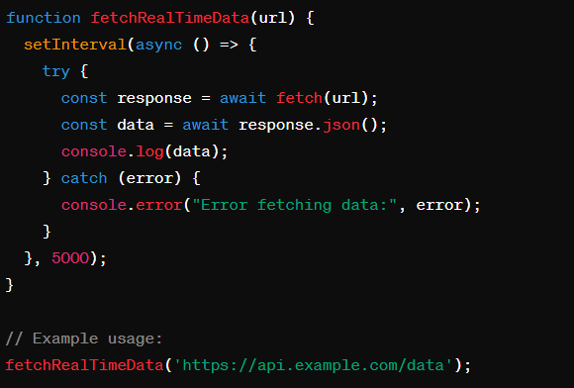

**Question 2: Advanced JavaScript Concepts**

Given the following code snippet, explain what will be logged to the console and why.

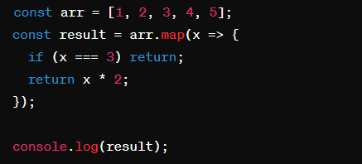

**Section 2: Theoretical Questions**

**Question 3:** Explain the concept of closures in JavaScript and provide an example.

**Question 4:** What is event delegation in JavaScript? How can it be useful in optimizing event handling?

**Question 5:** Describe the differences between null and undefined in JavaScript. When would you use one over the other?

**Question 6:** What are Promises in JavaScript? How do they differ from callbacks? Provide an example of using a Promise.

**Section 3: Coding Challenge**

**Question 7:** Async/Await Practice

Implement a function fetchUserData that fetches user data from an API using async/await. The function should take a userId as input and return the user's data if the request is successful, otherwise, it should throw an error.

